3. Test, Finalise, and Review a Prototype Game
Assessment type ():
☐ Questioning (Oral/Written)
☐ Practical Demonstration
☐ 3rd Party Report
☒ Project

Assessment Resources:
(List any specialised resources required by the student or the assessor in order to complete this assessment)

Assessment Instructions:
Overview
Having completed a working version of each of the projects, your task now is to test and complete each of the projects and document the process and the finished product in consultation with your client (the lecturer).

For this assessment, as with the last two, you will need to complete all of the tasks twice: once for each project.

1. Test and Improve the Game and GUI (0/4)
Over the course of developing these games you will need to perform testing, receive feedback from users, and implement changes to the project based on their feedback

2. Build and Finalise the GUI (0/3)
During the process of developing the GUI, keep a version history of the development. Once the GUI is completed, create a version of the GUI design document from Assessment 2 and present the finished GUI with all elements itemised and explained

3. Review and Evaluate the Project Design (0/1)
Review your game design and AI implementation in reference to the original design brief. Go over each point of the brief and explain how your design has addressed these requirements

4. Final Game Project (0/2)
For your final task, you must complete the project and submit the exported/finished build of the game and your final project folder

Evidence
Assessment 3 Document Completed
Final Project Build
Final Project Folder

Test and Improve the Game and GUI (0/4)

You will need to conduct 3 Tests with different testers in order to verify the game is working correctly and that the client is happy with the product, as well as catching bugs.

Note: One of the tests must specifically test the GUI and one of the other tests must have the client (the lecturer) as the tester

1. Test Plan and Setup (0/4)
Create a plan for the 3 tests. The plan should cover the following points:
- How is the test running (in a Build or in the Project)?
- What part of the game does the tester start in (main menu, game level, etc)?
- What steps will the test take (1. Introduce the user to the test, 2. Have test play the prototype, 3. Have tester fill out the feedback forms)?
- One of the tests should cover testing the GUI. How will you modify the test to focus on the GUI?
The plan for my tests are:

- Build the game, so it runs outside of Unity
- The game will start at the main menu, with full access to the menu GUI
- I’ll advise the tester of my game at a basic level, providing little to no detail. This ensures the instructions I’ve put in the game make sense, and the test can follow them
- Once the tester has finished playing the game, I’ll ask for informal feedback, I’ll then explain the game further as to how I envisioned it would run and then ask them to play it again and let me know what it’s lacking between their blinded run vs my envisioned run
- Once the tester has played the game a second time, I’ll ask them to fill out the feedback form
  - In terms of testing the GUI – I’ll remove delays between camera transitions and any blocking logic, allowing the tester to quickly try functionality without waiting for movement / bool’s to become true, etc

2. Test Feedback Forms (0/3)

Test Feedback Form 1 – Client Review (0/1)

- Name of the Test and the Date
Name: Thomas Devenish
Date: 21/05/2026
- Did the Game run correctly? Did you encounter any bugs during the test? If so, please explain what happened
Game ran well. It was possible to spawn an infinite number of aliens which does eventually cause the game to start spasming in the moments where they all attempt to find a path

The non-alien NPCs also start breaking because the pathfinding system is overloaded.

- Was the game enjoyable to play? Do you have any critiques?
The style and the fact that spawning enough enemies to break the pathfinding was the only way to slow the aliens was quite entertaining.

Only critique would be that there is no other way to slow the aliens down – some other mechanics might be fun.
- Did the Developer/the Game provide instructions on how to play? Were they helpful?
There was, however the font colour was a bit hard to read so I would recommend updating that

- Do you have any other feedback?
No

Test Feedback Form 2 (0/1)

- Name of the Test and the Date
Name: Dan Campbell
Date: 14/05/2026
- Did the Game run correctly? Did you encounter any bugs during the test? If so, please explain what happened
The game ran correctly.

- Was the game enjoyable to play? Do you have any critiques?
The game was amusing, but I'm not sure why I won! Tutorial text was very wide on a 21:9 screen.

- Did the Developer/the Game provide instructions on how to play? Were they helpful?
The game provided instructions, yes they were helpful. Run around, chase the aliens, spawn more aliens, all explained at the start.

- Do you have any other feedback?
Invert mouse controlssss!! And maybe that chicken could waddle a bit faster?
Ben’s note: I completed agree with Dan with inverted controls, so I’ve already updated the game to include them

Test Feedback Form 3 – GUI Focus Test (0/1)

- Name of the Test and the Date
Name: Thomas Robin
Date: 21/05/2026
- Did the Game run correctly? Did you encounter any bugs during the test? If so, please explain what happened
The only bug found was if you spawn too many aliens, the game starts to freeze, but this is also normal as we overload it.

- Was the game enjoyable to play? Do you have any critiques?
Yes, that’s a fun little game to play. The environment and the game theme match well together.

- Did the Developer/the Game provide instructions on how to play? Were they helpful?
Yes, and the in-game instructions are easy and well structured to play the game without further information needed

- Do you have any other feedback?
Nothing more than what’s here. GUI was easy to follow, no bugs found in it.

3. Testing Feedback Summary (0/1)
Summarise how the testing process went and if there was anything consistent in the feedback you received. Also discuss how the GUI focus test went. This should take 1-2 paragraphs

The testing process went well. I did not explain anything to the tests prior to starting the game, simply “please test my game”. I did this purposely because I wanted to test my in-game instructions. While I sat with the testers, I only answered direct questions from them, so I could ensure they had no outside influence on how the game should run, I preferred they figured that out themselves so I could get good quality feedback.

The feedback received was overall good. Main points being controls were inverted and should be swapped and hard to read introduction text. Both of which I agreed with and have adjusted in the final version.

The GUI focus test was a tricky one, as the game was tied around clicking a button to start, then reading the intro text, but by removing the timings between button clicks, it allowed the testers to quickly try out menus without needing to wait for in-game actions to finish.

4. Feedback Implementation Summary (0/1)
Having received feedback from users and from your client, explain how you went about implementing these changes. If applicable (especially with the GUI) provide before and after images demonstrating the changes.

If there were not that many things to address then you can add to this by mentioning any additional changes you made that were not directly mentioned in user feedback but may have been influenced by the testing process

Introduction Screen prior to changes | Introduction Screen after changes
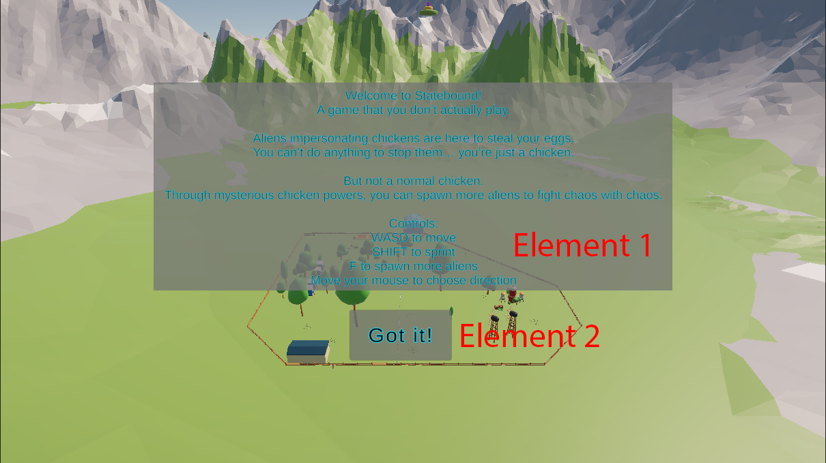 | 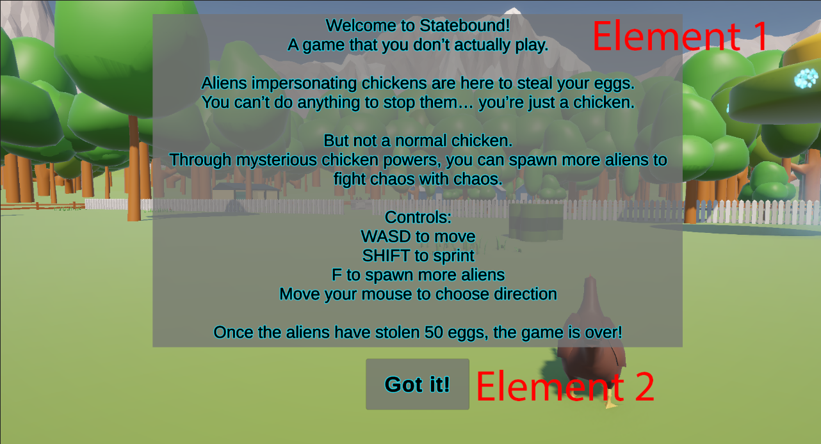

Above are the changes made to the introduction screen, showing how hard it was to read prior to the change. This was noted in all test cases.

For this change, I increased the font size and lowered the blue outline slightly so it wasn’t so harsh.

Build and Finalise GUI (0/3)

Main Menu:
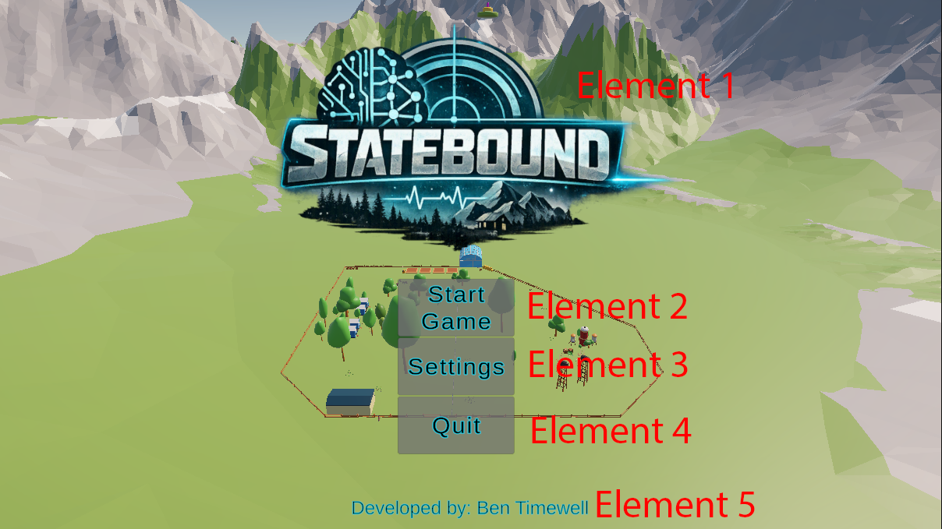

Element 1 – Game Title and Logo
This just shows the name of the game and its logo (The logo was generated using ChatGPT)

Element 2 – Start Game button
This button hides the main menu, and begins the game

Element 3 – Settings button
This button hides the main menu, and shows the settings menu

Element 4 – Quit button
Quits the game instantly

Element 5 – Attribution
Just a cheeky credit section

Settings Menu:
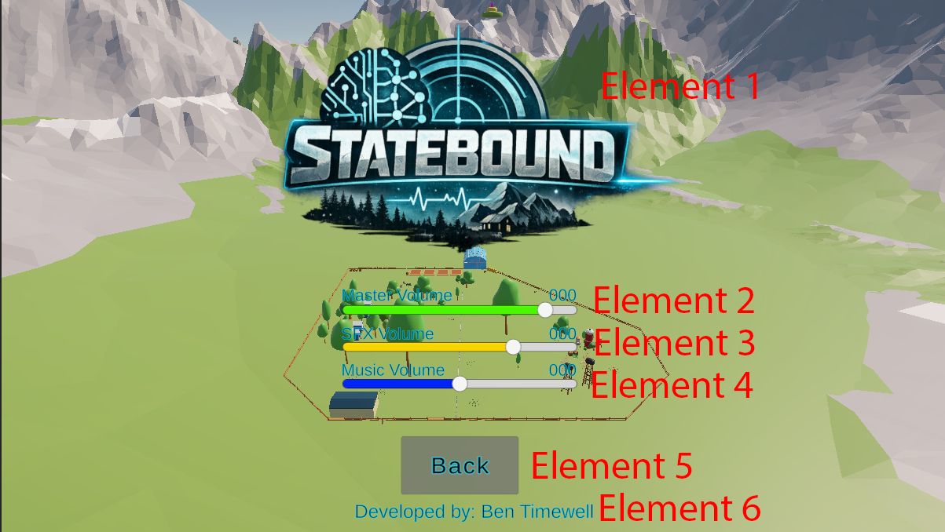

Element 1 – Game Title and Logo
This just shows the name of the game and its logo (The logo was generated using ChatGPT)

Element 2 – Master Volume slider
This is an independent volume slider that adds a modifier to the sound effects and music volume levels, essentially controlling all audio at once

Element 3 – Sound Effects Volume slider
Independently controls the sound effects volume in the game

Element 4 – Music Volume slider
Independently controls the music volume in the game

Element 5 – Back button
This hides the settings menu or pause menu, depending where you clicked the settings button originally and shows the main menu or the pause menu, essentially returning the player to where they were before pressing the settings button

Element 6 – Attribution
Just a cheeky credit section

Win Display:
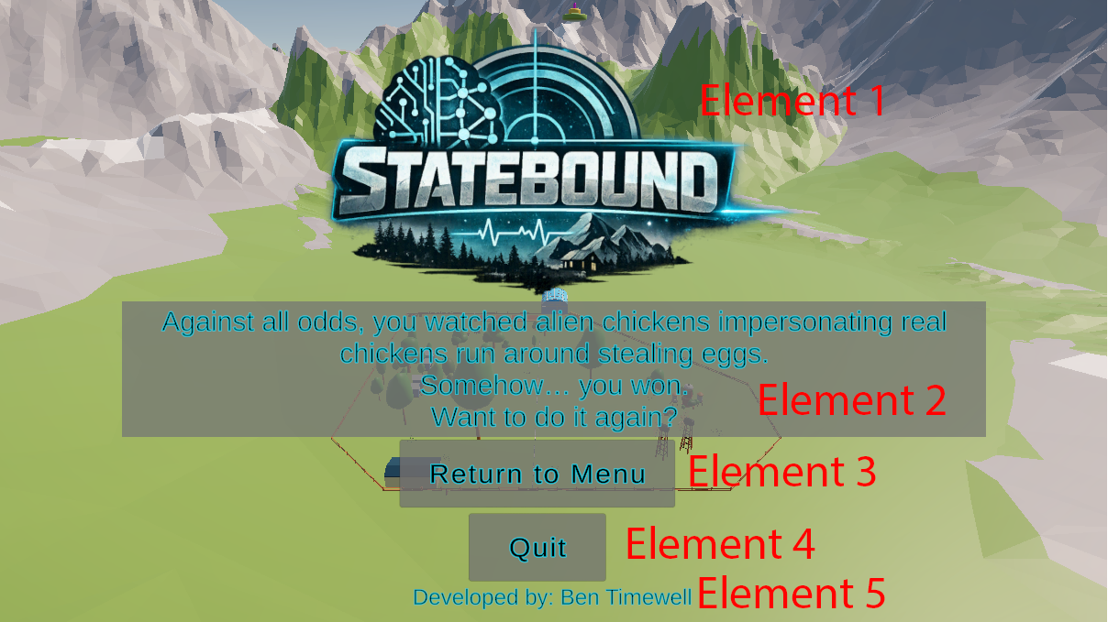

Element 1 – Game Title and Logo
This just shows the name of the game and its logo (The logo was generated using ChatGPT)

Element 2 – Win text
This displays to the player that they’ve won the game

Element 3 – Return to menu button
Returns the player the main menu

Element 4 – Quit button
Quits the game instantly

Element 5 – Attribution
Just a cheeky credit section

Pause Menu:
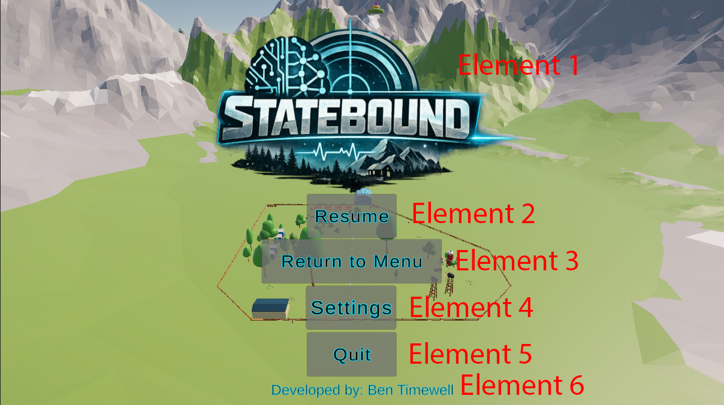

Element 1 – Game Title and Logo
This just shows the name of the game and its logo (The logo was generated using ChatGPT)

Element 2 – Resume button
This resumes time scale back to 1 and resumes the game

Element 3 – Return to menu button
Returns the player the main menu

Element 4 – Settings button
This button hides the pause menu, and shows the settings menu

Element 5 – Quit button
Quits the game instantly

Element 6 – Attribution
Just a cheeky credit section
Game Play Screen:
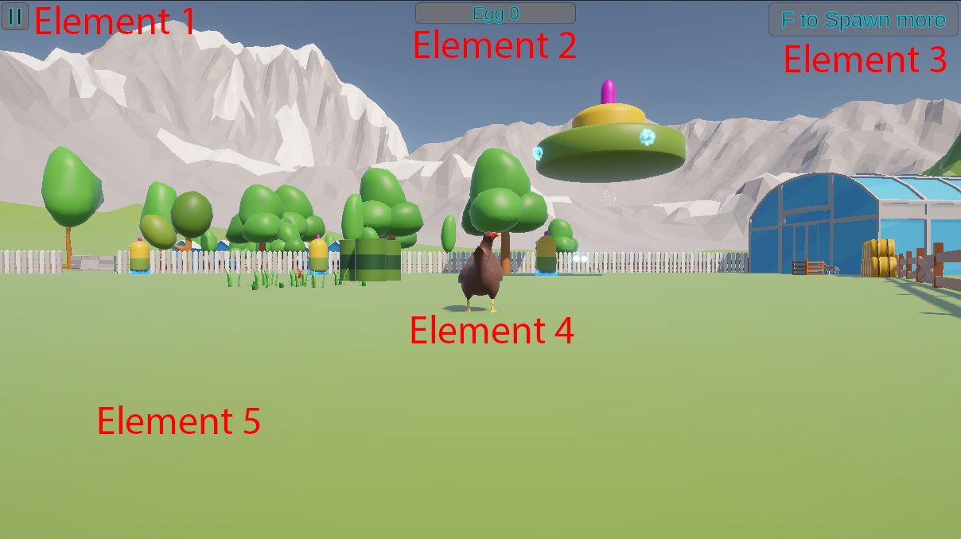

Element 1 – Pause button
This sets the time scale to 0 and brings up the pause menu

Element 2 – Resource counter
This shows the player the current number of collected resources

Element 3 – Spawn NPCs button
This button, when pressed will spawn 1 additional NPC under the spacecraft. Also pressing “F” will spawn another NPC

Element 4 – Player Character
In this game, the player controls this chicken. It has no special moves, items or identity. It simply exists to explore the world, while watching the aliens steal eggs. Controlled via WASD, SHIFT for sprint and mouse pointer to change facing direction

Element 5 – Gameplay field
The rest of the screen is the gameplay field. The player will watch the NPCs go about their lives in this section

Intro Text Screen:

Element 1 – Introduction Text
This explains to the player the basics of the game, such as a very rough story as well as controls

Element 2 – “Got it!” Button
Once pressed, this sets the time scale to 1, hides the intro text and spawns 5 NPCs under the spaceship that lands, seen just before this screen appears.

Version History (0/1)
List any changes made from the original mock-up of the GUI up until the final version. The only changes may be that assets were created/sourced. Please include this as well as what order in which the functionality of each element was created

- I added the introduction screen to appear after the player hits the “Start Game” button
- Added a settings button to the pause screen, so the player can access settings while in game rather than just the main menu
- I removed the original tree / get wood design and remade the game as “aliens stealing chicken eggs”. This meant I got an entire new asset pack.
  - New assets include:
    - Chicken coops
    - Different tree types
    - Chicken feeders
    - Wind mills
    - Warehouses / barns
    - Fences
    - Farm land
    - Chicken the player can control
In terms of the order, I made the new menu items first as that was a core item that was needed regardless of the theme of the game, and once that plus the logic behind it was working, I went about making a new landscape. While searching for “wood” related assets, like logging machines / chain saws / lumberjacks, I found I didn’t overly like the theme and opted to go for a farm yard instead. Since I was using my original “PTSD Chicken” (As Tom calls them) asset, from the prototype, I decided to turn them into “aliens disguised as chickens”. Once I had that idea locked in, I made a space ship asset for them to arrive in and started building the world environment. This included putting down trees, random farm yard things, setting up fences, making the world become a world essentially. After the world was constructed, I setup the player controlled chicken, so the player can explore the world. At that point, it was down to testing and adjusting.

Review and Evaluate the Project Design (0/1)
In this section you will need to address the brief from Assessment 1. For each point, explain (in the column on the right) how your project met the requirement. As before, stretch goals are NOT required

Point from the Brief | How it was Implemented (0/12)
1. Be in 3D | Using the Universal 3D template in Unity Hub when creating the project
2. Incorporate 3D animations and visual assets | 3D animations are implemented by the various NPC animals around the farm. They have idle animations that play on a loop, and the player controlled chicken also animates while walking around / also has idle animations.  Visual assets were implemented by sticking to a farm style theme, these were placed around the world space
3. Include some sounds – at least some background atmosphere | There are a few sounds in the game. There is background music that plays on a loop, the spaceship when landing plays a “wooooshhh” sound and the various NPC animals make animal noises. All sound is controlled by an audio mixer, with separate controls for music and SFX sounds.
4. Have some level of Graphical User Interface to display information to the player | Once the player starts the game, the total number of collected eggs appears in the top middle of the screen, indicating how many eggs the aliens have collected.
5. Include at least a Main Menu for entering the game and a way to Exit the game at runtime | The game has several menus. The first screen the player sees is the main menu, which allows the player to start the game, go into settings and adjust volume or exit the game instantly.
6. Have Non-Player-Characters (NPCs) that act independently based on their role (such as a logger, miner, farmer etc) using some level of decision making and planning | I have implemented one NPC type that acts independently from its clones. Each NPC has its own hunger meter and inventory, so when hunger is running low for one NPC, only that NPC goes and eats while the others continue their stealing egg tasks. And when an egg is delivered, other NPCs don’t lose their egg.
7. Incorporate pathfinding solutions so that NPCs can Navigate the 3D world. In relation to this point, the client also wants to have 2 Pathfinding systems demoed in separate scenes in this prototype:  Navmesh  A* Pathfinding | The main scene (Main Game – NavMesh) uses NavMesh for it’s path finding. The NavMesh surface is added to the “Ground” game object, located in Level -> Enviroment -> Terrain within the scene. Then the Prefab “NPC” has the NavMesh agent component added to it.  A* Pathfinding was implemented in the “Prototype – Astar” scene. This is the basic prototype of the game, graphics and world space have not been updated in this scene, but it does use A* Pathfinding. Switching scenes is done by pressing the A* button on the main screen, and then the NavMesh button on the A* prototype scene.
8. Have at least 1 NPC type that can be spawned by the user during gameplay | The player can spawn an alien by pressing F or clicking the “F to spawn alien” button. This spawns 1 extra alien below the spaceship. Continued clicks will spawn extra aliens.
9. Have a resource system tracking at least one resource in the game | I am tracking the stolen eggs. This is done by having the “Inventory Displayer” script attached to the spaceship game object. It observes the amount of stolen eggs inside the spaceship inventory and displays the total amount in the top middle of the screen. This is also the win condition script, once 50 or more eggs are in the inventory, the win screen appears
10. Have Locations such as buildings and natural resources in the game that NPCs can interact with | The game has 4 main locations:  - Egg Coop: Where aliens get and steal eggs  - Silo: Where chicken feed is stored and where aliens go to eat to replenish hunger  - Bucket Spawn: This is where aliens pickup buckets to then carry eggs to the spaceship  - Spaceship: Where aliens spawn and deliver stolen eggs too
11. Have an end-condition upon a particular resource meeting a certain threshold | The end condition is when the aliens steal 50 eggs and deliver them to their spaceship.
12. Some form of Item system for the various resources and tools in the game | The game has three main items:  - Stolen Eggs: The eggs that are stored in the Egg Coops  - Chicken Feed: Food that is stored in the silos  - Buckets: These are needed to steal the eggs. Aliens will go and get them before attempted to steal eggs.
Stretch Goals | How it was Implemented
Multiple NPC types (such as farmer, miner, logger, cook, etc) | N/A
Multiple Resources in the game | N/A
Multiple Item types | N/A
Hunger system | Hunger slowly drains as the aliens steal eggs. When it gets too low, they’ll finish their current tasks and go eat from the chicken feeders. They eat Chicken Feed.
Day and night system | N/A
Multiple factions | N/A
Animal NPCs | There are animal NPCs, but they’re more assets than actual GOAP AI NPCs. They do however have a NavMesh agent added and have waypoints they walk around to. There’s no logic in them, just move to position X, avoid obstacles, then move to position Y.
Combat system and/or Hunting system | N/A

Final Game Project (0/2)
Submit the Prototype in both Build and Project Folder forms

1. Project Build (0/1)
Submit the final project build in a .zip file

2. Final Project Folder (0/1)
Submit the final project folder in a .zip file

